1.Create two repository (Tushar as Private and assignment as Public)

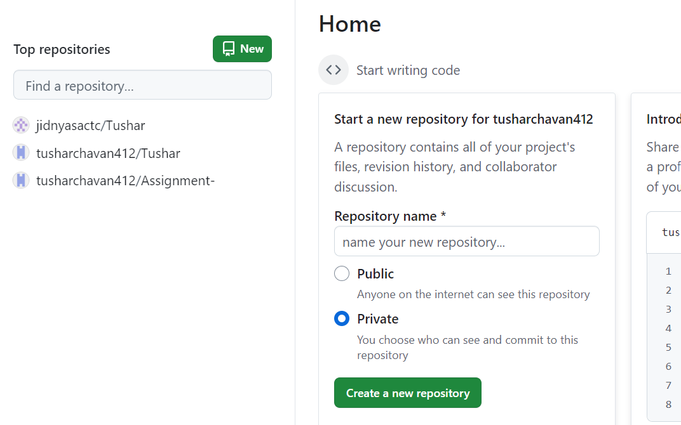

2. create ec2-instance & create index.html & push on central repository (Tushar)

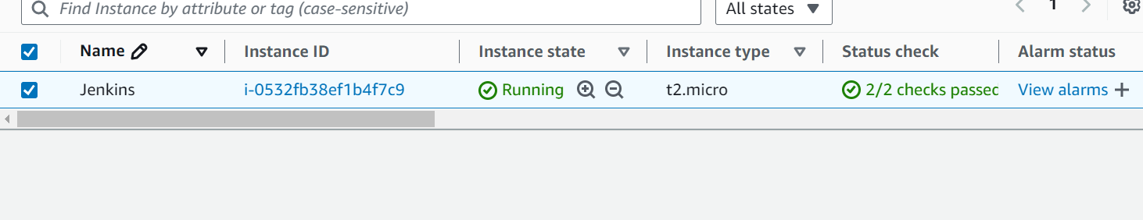



[root@ip-172-31-8-6 mnt]# git init

hint: Using 'master' as the name for the initial branch. This default branch name

hint: is subject to change. To configure the initial branch name to use in all

hint: of your new repositories, which will suppress this warning, call:

hint:

hint: git config --global init.defaultBranch <name>

hint:

hint: Names commonly chosen instead of 'master' are 'main', 'trunk' and

hint: 'development'. The just-created branch can be renamed via this command:

hint:

hint: git branch -m <name>

Initialized empty Git repository in /mnt/.git/

[root@ip-172-31-8-6 mnt]# ll

total 4

-rw-r--r-- 1 root root 1114 Oct 5 02:17 index.html

[root@ip-172-31-8-6 mnt]# git status

On branch master

No commits yet

Untracked files:

(use "git add <file>..." to include in what will be committed)

index.html

nothing added to commit but untracked files present (use "git add" to track)

[root@ip-172-31-8-6 mnt]# git add index.html

[root@ip-172-31-8-6 mnt]# git status

On branch master

No commits yet

Changes to be committed:

(use "git rm --cached <file>..." to unstage)

new file: index.html

[root@ip-172-31-8-6 mnt]# git commit -m " New file update "

[master (root-commit) 529e9fa] New file update

Committer: root <root@ip-172-31-8-6.ap-south-1.compute.internal>

Your name and email address were configured automatically based

on your username and hostname. Please check that they are accurate.

You can suppress this message by setting them explicitly. Run the

following command and follow the instructions in your editor to edit

your configuration file:

git config --global --edit

After doing this, you may fix the identity used for this commit with:

git commit --amend --reset-author

1 file changed, 40 insertions(+)

create mode 100644 index.html

[root@ip-172-31-8-6 mnt]# ll

total 4

-rw-r--r-- 1 root root 1114 Oct 5 02:17 index.html

[root@ip-172-31-8-6 mnt]# git log

commit 529e9fa2ff4acccdc08ed0d46cf74d895c336cc4 (HEAD -> master)

Author: root <root@ip-172-31-8-6.ap-south-1.compute.internal>

Date: Sat Oct 5 02:22:07 2024 +0000

New file update

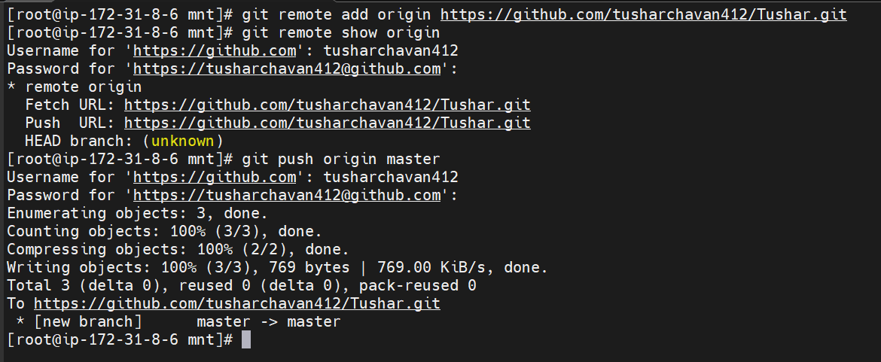

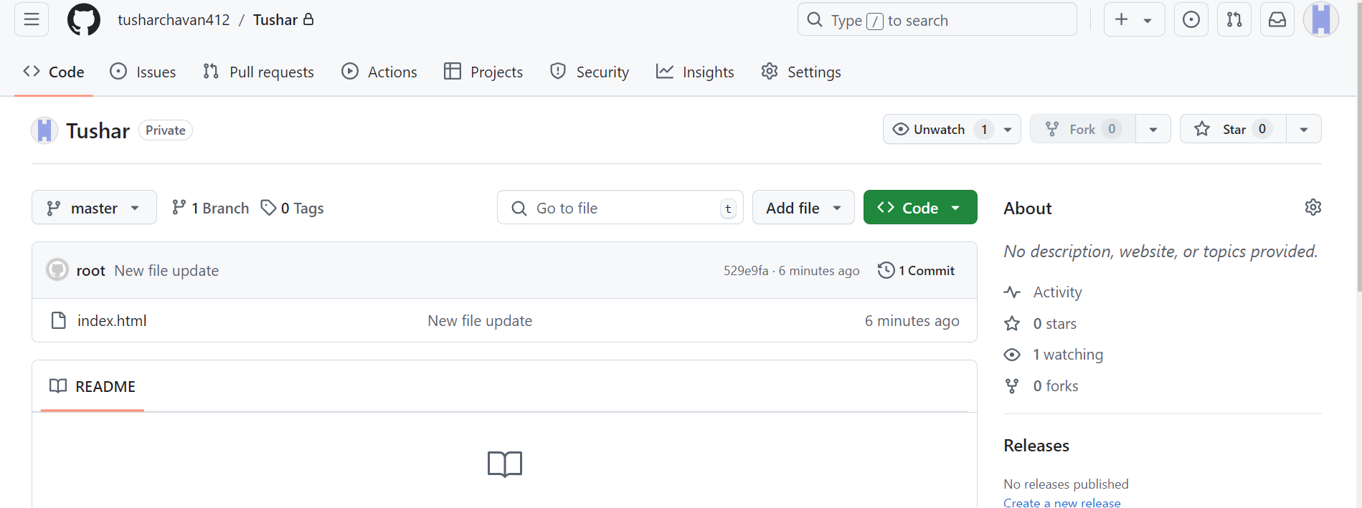

Successfully push index.html on central repository.

3. install Jenkins through web application

4 Install java & apache-tomacat

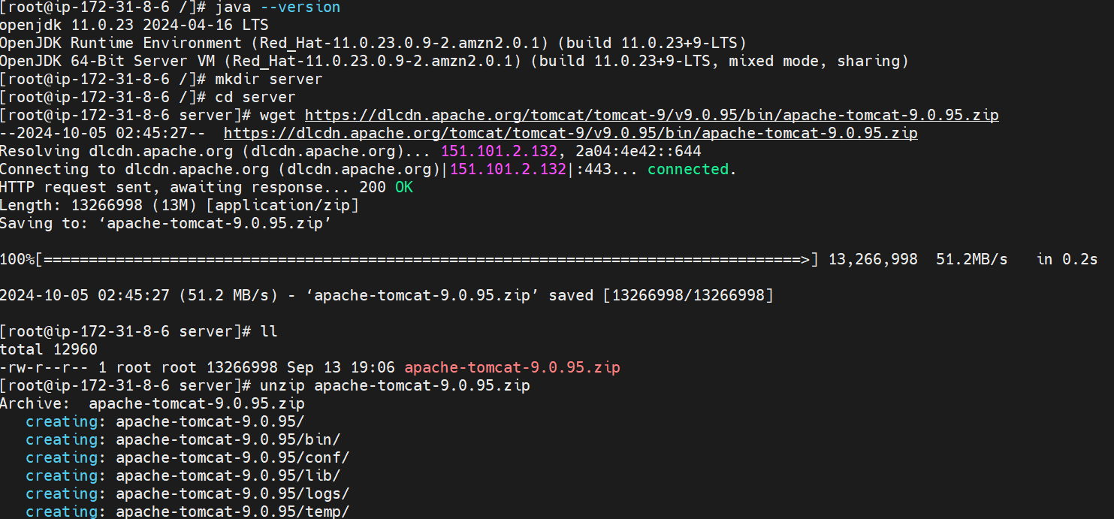

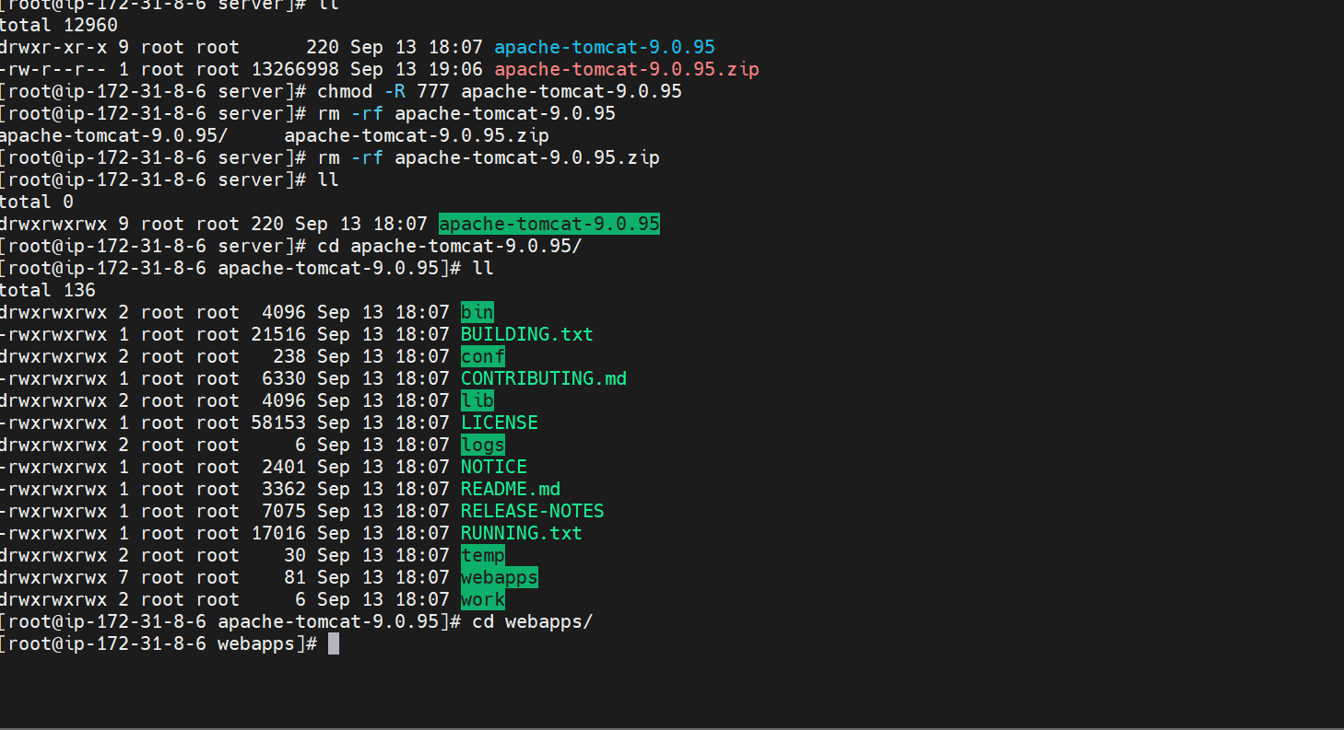

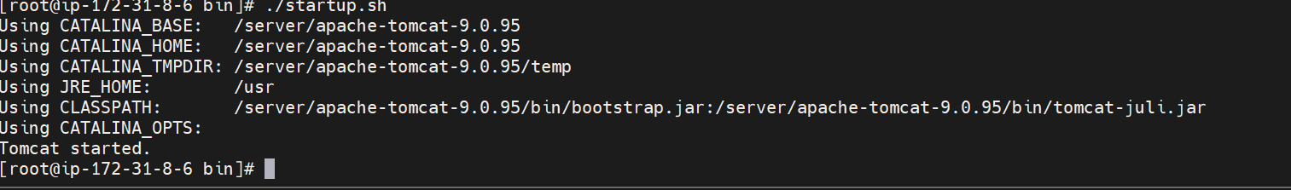

Tomcat started successfully. Now go to in security group & check 8080

After hit IP address:8080/Jenkins/

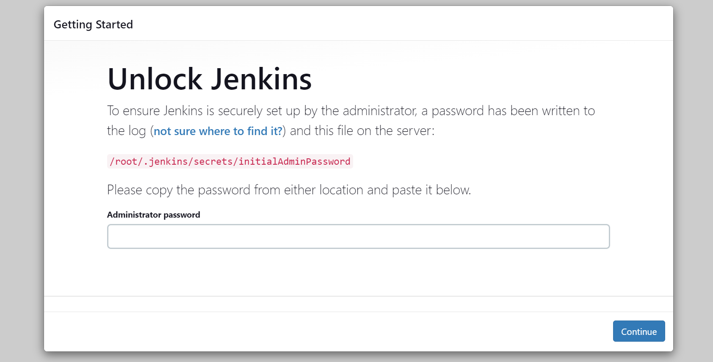

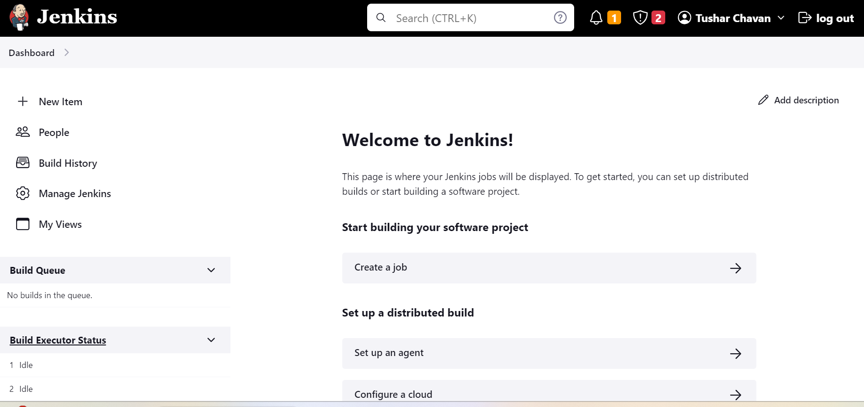

Create one job (New project)

Configure private git repository and add secrete access key.

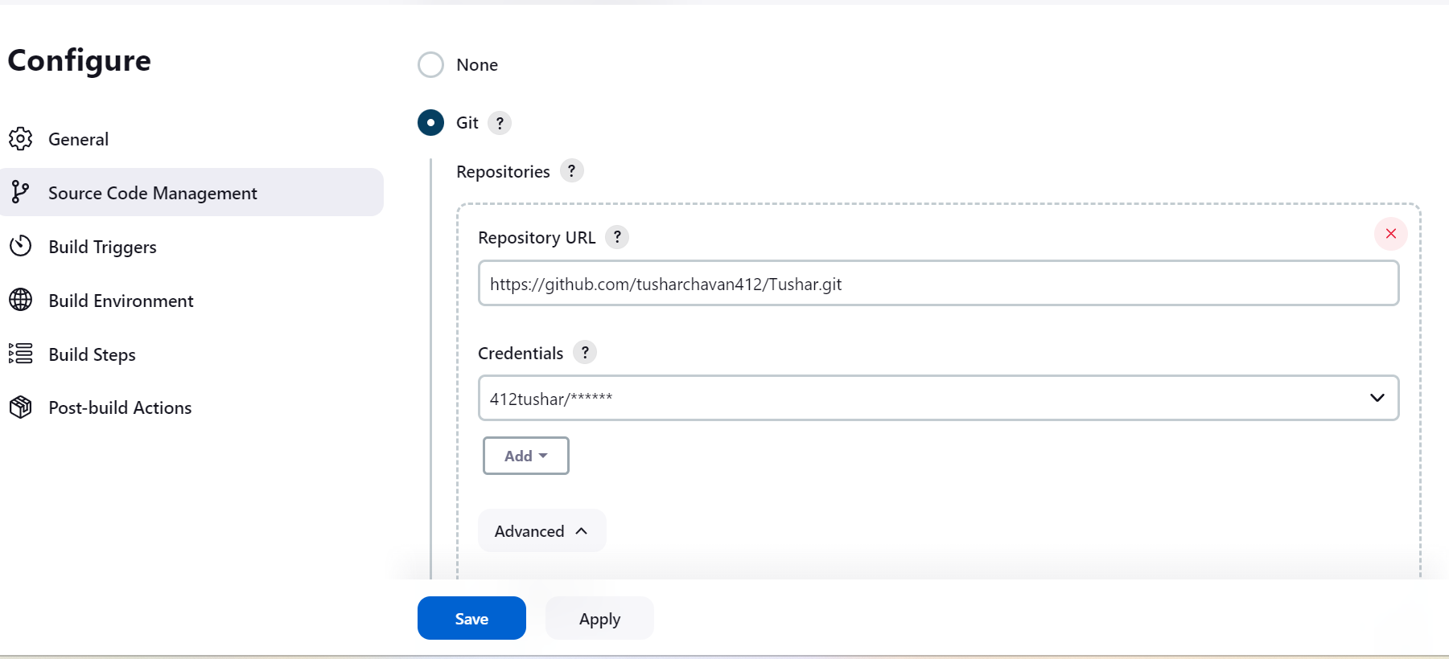

After integration git then click shell script

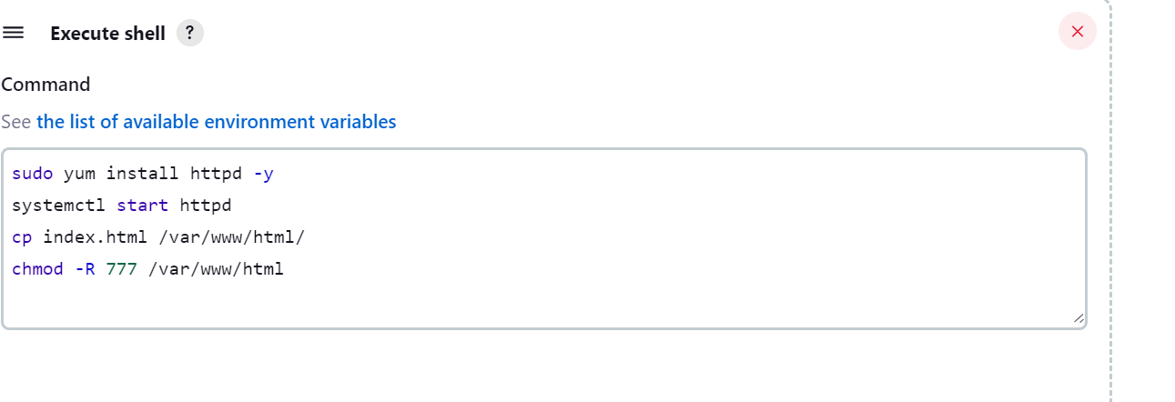

Then Apply & save then build the code.

Output : hit the IP address in Brower

